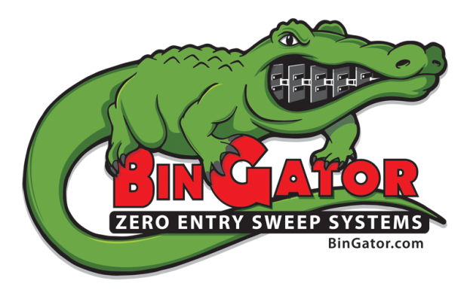
Bin Gator – Request for Quote
Please supply as much information as you can. If you don’t know – don’t worry. We will contact you by phone before preparing your quote.

ABOUT YOU…

Name:__________________________________________ Title:________________________________
Company:______________________________________ Website:______________________________
Address:___________________________________ City:_________________ State:____ Zip:________
Phone: ( ______)_______ -_________ Ext:______ Alternate Phone (Cell): (______)_______ - ________
FAX:(______)________ - _________ Email:_________________________________________________
I’d prefer my quote(s) sent by (check one): [___] Email (default) [___] FAX [___] U.S. Mail
We will generally give you a follow-up call a few days after you receive your quote to see if you have any questions. Or you may call us any time!

ABOUT YOUR BIN GATOR…

Diameter of Bin:_______ ft (Note: The Bin Gator is not available for FULL FLOOR aerated bins)
Height: _____ Rings [_] 32” [_] 44”? …or… Eave or Peak:_______ [_]E [_]P …or… Bushels:________
Commodity: [__] Corn [__] Beans [__] Wheat [__] _______________
Reclaim Bushels Per Hour:______________ Center Sump Size:_________ X _________
Voltage Requirements: [__] 240 Volts [__] 480 Volts [__] 575 Volts (Canada)

Now What?

That’s all we need to know. And if you couldn’t answer every question, don’t worry. We’ll figure it out.
You may Email this form to sales@bingator.com You can FAX this form to us at (815) 538-3087.
Or mail it to us at Prairie Land Millwright, 617 E US RT 34, Mendota, IL 61342

